NTI Summer Training Program
Student Assignment
Assignment 2 - Developing a Pricing Structure Foundations & Developing a Pricing Structure - Packages and Negotiation
A practical written task to calculate a fair price, build service packages, and respond to a pricing objection.
Session | Session 2: Developing a Pricing Structure Foundations & Developing a Pricing Structure - Packages and Negotiation | Assignment Type | Individual Written Task
Assignment Title | Freelance Pricing and Negotiation Plan | Total Marks | 20
Submission Format | Written document only - no audio or video | Suggested Length | 1-2 pages
Student Name | Osama Ahmed Abdelaziz | Student / User ID | 313513
Assignment Brief
One Practical Assignment
Use the freelance service you selected in Assignment 1, or choose one realistic service. Create one written Pricing and Negotiation Plan for a client who wants to hire you.
- Estimate the required time, effort, business costs, and profit, then select and justify an appropriate pricing model.
- Create Basic, Standard, and Premium packages with clear deliverables, timeline, revision limits, and prices.
- Write a professional response to a client who says: “Your price is too high. Can you reduce it?” Protect your value and offer a suitable option.
Required Written Submission
Final Output | - Pricing calculation and selected pricing model with a short justification.  - Three service packages: Basic, Standard, and Premium.  - Pricing-objection response of 80-120 words.
Evaluation Rubric - 20 Marks
Criteria | Marks | What the trainer will check
Price calculation and model | 5 | Price considers time, effort, costs, profit, and uses a suitable pricing model.
Package structure | 5 | Packages show clear differences in deliverables, timeline, revisions, and price.
Negotiation response | 5 | Response is confident, professional, value-focused, and offers a reasonable option without weakening the service.
Formatting and language | 5 | Submission is clear, organized, readable, and professionally written.
Submission note: The assignment must be completed in writing only. Do not submit voice notes, videos, or presentation recordings.

1. Pricing Calculation and Pricing Model

Freelance Service: Web Development for Small Businesses and Medical Clinics
Selected Pricing Model: Project-Based Pricing
I chose project-based pricing because it allows the client to know the total cost before the project starts. It also allows me to price the service according to the required work, complexity, time, and value delivered rather than charging the client for every hour.
Estimated Pricing Calculation
- Estimated work: 15 hours
- Target hourly rate: $10/hour
- Estimated work value: 15 × $10 = $150
- Business costs: $20
- Expected profit: $30
- Final project price: $200
Therefore, I would use $200 as the price for the Standard package because it covers my expected time, costs, and profit while remaining reasonable for a beginner freelancer.

2. Service Packages

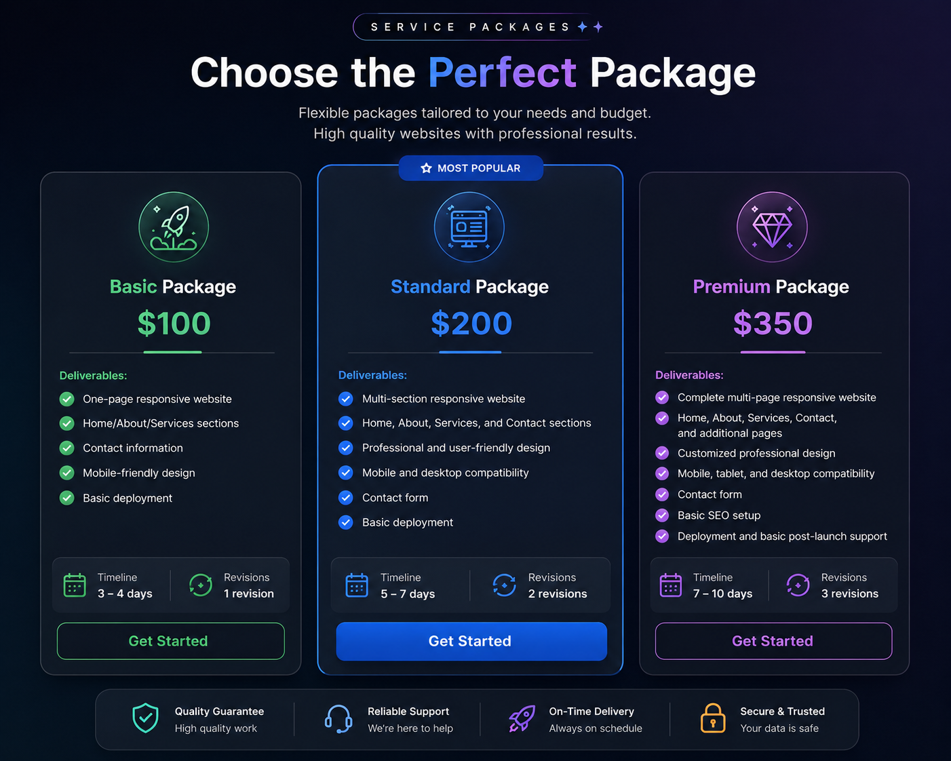

3. Response to a Pricing Objection

Client: “Your price is too high. Can you reduce it?”

Thank you for sharing your concern. I understand that budget is an important part of choosing a service. My price is based on the time, development work, testing, and support required to deliver a professional and responsive website. Instead of reducing the quality of the Standard package, I can offer the Basic package at $100 with fewer features and one revision. This gives you a more affordable option while still providing a professional online presence. If you prefer the Standard package, I would be happy to discuss which features are most important and adjust the scope to match your budget.

